WeiHong Engraving machine movement control system Ncstudio™ Version 5.4

Software manager handbook
In January, 2004
Shanghai WeiHong Science and technology Limited corporation

Thank you to choose this company's product!
This handbook helps you to be familiar with this company’s product, knows the information about composition disposition aspect of system.
This datum introduce particular that the installation process and each function on system , before using this software system and the correlation engine bed equipment, asks you to read this handbook in detail. This will be helpful to you uses it well.
As a result of the software, the hardware have been updated incessant, the software and hardware which you receive possible to have the discrepancy in certain aspects with this handbook statement. Shows the apology sincerely in this.

Contents

Promotion record
Contents
- Outline
  - Software characteristic
2. System installment and connection
2.1 Ncstudio™ System basic disposition
Computer main engine
Operating system
2.2 Ncstudio™ System Install
Install Ncstudio™ software
Install Ncstudio™ Control-card
Restart computer
2.3 Other install question
2.4 Uninstall the Ncstudio™ system
2.5 Connection Ncstudio™ Control-card and Actuation system
3.Ncstudio™ Basic concept
3.1 Operation pattern and status
Operation pattern
Operation status
3.2 Engine bed coordinate system
Machinery coordinate system
Workpiece coordinate system
4. Ncstudio™ Operation contact surface
4.1 Title bar
4.2 Menu bar
4.3 toolbar
4.4 Numerical control information fence
4.5 Status fence
4.6 Numerical control Status fence
Processing status and time information
Current position
Feed rate
Engine bed control
4.7 Automatic window
4.8 Manual window
4.9 trace window
Three-dimensional view pattern
Context menu
Establishment personalization parameter
4.10 log window
4.11 file manager window
4.12 parameter window
Machining
Parameter
4.13 “editor” window
4.14 I/O state window
5. Menu system
5.1 “File” menu
Open and load
Unload
New
Open and edit
Edit loaded file
Save
Save as
Save and load
Close
Recent loaded file
Recent edited file
Exit
5.2 “edit” menu
5.3 ‘view’ menu
Tool bar
Status bar
Full screen
Show file line number
Trace current line
File information..
5.4 “operation” menu
Click bar
Set workpiece origin
Set workpiece coordinate
Current coordinate
Move to workpiece origin
Start
Pause
Stop
Enter simulation mode then start
Advanced start
Resume
Advanced MDI
Jiggle
Calibrator
Move to reference point
Replacement
Disable mechanical limits
5.5 “machine” menu
5.6 “windows” menu
5.7 “help” menu
6. Operation step
6.1 Starting
6.2 Machine replacement
6.3 load processing program
6.4 Manual operation
6.5 Determination workpiece origin
6.6 Execution auto processing
6.7 Direct localization function
7. Operation attention
7.1 Multi-duty execution attention
7.2 Move to workpiece origin attention
8. End-manager software permission agreement
9. Appendix: Quick key data sheet
9.1 Overall situation quick key
9.2 Manual windows quick key
9.3 Trace windows quick key

1.Outline
Ncstudio™ numerical control system is the Shanghai Weihong Science and technology Limited corporation independent development, the innate copyright engraving machine movement control system, This system may support UG, MASTERCAM, CASMATE, Art CAM, AUTOCAD, CorelDraw directly and so on many kinds of CAD/ CAM software produces G code, PLT code format and extractive-carve processing document ENG code format .
Ncstudio™ Based on the operation system of Microsoft Windows, exerts 32 computations and the multi-duty formidable predominance fully. At the same time, the standard Windows style manager interface has the merit which the operation simple reliable, simple easy to study.
This numerical control system except has the function of manual, step-by-steps, automatic and returns to the mechanical origin, but also has the simulation, the dynamic show track, the Z axis calibrate tools automatic, the break point memory (procedure jumps automatically section execution) and the gyro-axis processing and so on the function peculiar.
This system may uses together with each kind of three-dimensional engraving machine, the three-dimensional carving-milling machine. It is suitable in each kind of complex mold processing, advertisement decoration, cutting way and so on.
  - Software characteristic

This software has included the following function:
1) The basic disposition is three motive axles, and it may expand further;
2) Numerical control turn plate support;
3) Automatic processing. It supports the G instruction ISO the standard, the HP plotting machine (HP PLT) format and the extractive carver process format (ENG) completely.
4) Manual function. Not only supports the input device through engine bed, like the hand-hold equipment and so on the engine bed operated, but also supports in inlays input equipment through the computer, like the keyboard, the mouse complete the manual operation.
5) Increment feed function. The manager establishes precisely to feed quantity convenient, and the length of step may adjust nimbly.
6) Manager data input (MDI) function. The manager may input the G instruction online and carry out immediately
7) Advanced processing instruction. Inputting several parameters simply may complete the functions like the mill bottom, walk-frame and so on.
8) Single-step pattern. The manager may the processing duty which must carry out establish as the click-step pattern, accordingly it has provided the good support for the wrong diagnosis and the resume malfunction.
9) Advanced automatic function that the break point memory, jumps the section execution and so on
10) The function of the workpiece origin Save/Resume.
11) The function that feed axis returns to the mechanical origin precisely (reference point).
12) The function of calibrate tool Automatic. These functions have provided enormous convenient for the manager processing
13) Percentage feed adjustment online. The manager may adjust the percentage feed at any moment in the processing process, minimum to 0 that be quite to pause processing, maximal to 120%.
14) High velocity smooth velocity connection characteristic. In the general numerical control system, connection velocity between two G instruction is usually a fixed value (For example is equal to the zero or some very small value), In new edition numerical control system, it used the algorithm processing velocity adaptive prediction, This algorithm basis on connection velocity size, direction, maximum acceleration, as well as front forecast function, Decides the engagement velocity automatically between the current instruction and the next instruction, Not only enhanced the processing efficiency greatly(maybe from 30% to 300%), but also improved the workability, Eliminated the shake veins has kept on the surface of processing again.
15) Three dimensional simulation display function, Through the simple operation may from each angle observe the result of three dimensional processing, thus may more accurate and more direct-viewing to have the understanding for the result processing.
16) Simulation function, May carry on the fast simulation processing to the processing procedure, May complete in extremely short time, simultaneously inspects the processing procedure whether makes a mistake, whether the processing result does satisfy, and may computes accurate the time actual processing needed.
17) Formidable, flexible keyboard support. The support the operation of new edition to the keyboard is extremely formidable. Has contented the manager's needs in operating process.
18) Diary function. The system has provided the diary function formidable that helps the manager examination detailed processing information and the system diagnosis
19) In sets processing document supervisor. The manager saved the processing procedure file to the content appointed, the Ncstudio™ may manage these documents in the supervisor in sets.
20) In sets document editor. The manager may call in the processing document in the editor to edit or modify as necessary.
21) Document processing information. Through the simulation or the actual processing, the windows of the document processing information help that the manager statistics the information important about document execution time, the processing scope and so on.
22) PCI main line control-card

2. System installment and connection
2.1 Ncstudio™ System basic disposition
Host Computer
CPU: Pentium (586) or more
Memory: 32 M more
Hard disk: 2G more than
Display card: Supports 800*600 at least, tone up the color pattern
Display: 14VGA more
CD-ROM: 4 times fast or higher
Mainboard expansion slot: PCI slot or ISA slot 1
Operating system
Microsoft Windows 98 Chinese version operating system, or
Microsoft Windows Me Chinese version operating system, or
Microsoft Windows 2000 Professional Chinese version operating system, or
Microsoft Windows XP Professional Chinese version operating system

Then, How determine oneself operation system installed whether conform to the requirement? Opens the control panel of Windows, double-click “the system” icon, the system pop-ups “the system attribute” dialog box, the following chart shows. T attention observes this edition.
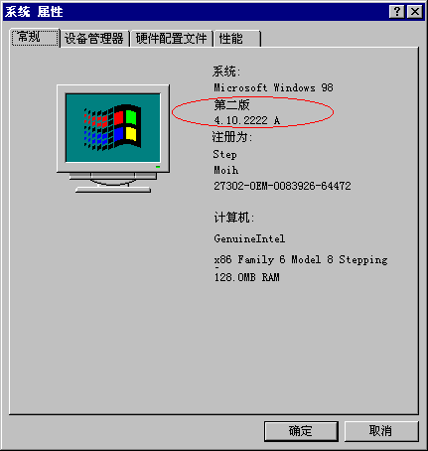
Attention:
Here shows the content basis different managers differs from, here gives the content only supplies the reference.
2.2 Ncstudio™ System Install
Before installs the Ncstudio™ newly, please deleted the old edition. The deletion method refer to section one about the procedure unload please.
The Ncstudio™ system includes software and control-card two parts. Therefore, the system installment also divides into two stages: Software installment and control-card installment.
As a whole, asked you to install the control-card after the software installed, such control-card driver does not need to install alone. Therefore simple said, it may be divided into such several steps:
- Installing the Ncstudio™ software, closes the computer after the installation procedure prompted shutting down computer;
- After closed the computer, install the control-card;
(3) Restarting the computer, waited for a moment after entered the Windows operating system, while Windows to complete the collocation automatically, the whole erection work completed.
(4) Move the Ncstudio™ system.
Below introduces steps in detail.
Install Ncstudio™ software
Please installs the software defer to following steps:
(1) Turns on the computer power, starts the computer, the system moves automatic and enters the Windows operating system. If you have not installed the Windows operating system, please first install this operating system.
(2) After Windows operating system start, the attention is that please closes other the procedure moving.
(3) Installs the compact disc of Ncstudio™ system to put in CD-ROM.
(4) Double-clicks “my computer” the icon, double-clicks the light to CD-ROM symbol after opens again. After waits the compact disc to open, found SETUP.EXE document, double click. Then the display appears the installation picture (e.g. chart)

(5) Clicks “the next step”, the system prompt choice the position install (e.g. chart)
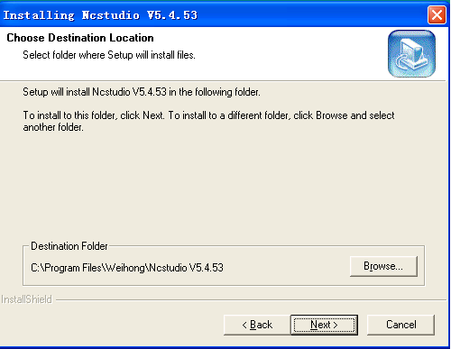
(6) Clicks “next step”, system prompt choice procedure folder (e.g. chart)
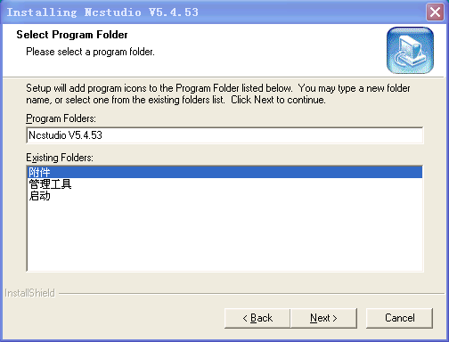
(7) Clicks “the next step”, the system prompt starts to copy the document (e.g. chart)
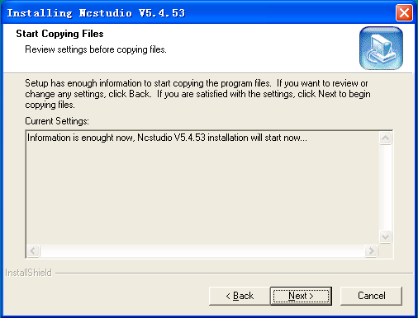
(8) Clicks next step, the system completes the document copy process automatically. And prompts to closing the computer immediately.
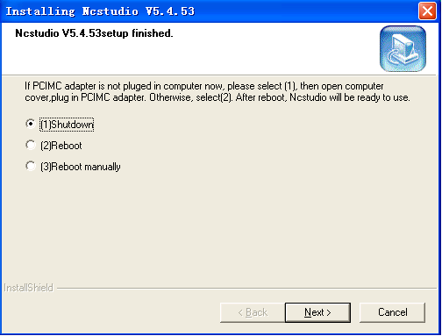
Please choose closes the computer immediately. After the computer closed, starts to install the control-card
Install Ncstudio™ Control-card
Closes host computer power, turns on the engine case lid, inserts the control-card to expansion slot which any vacant and the receptacle format match, inserts control-card.
When installs the control-card, with handles press gently the control-card both sides, guarantees the control-card have been inserted in the slot reliably, with the computer mainboard contact good, reliable, moreover does not have the situation which sways, then tightens the board card the fastening screw, finally covers the box lid, control-card installment completed
Restart computer
Installs the control-card, please start the computer. Starts the computer after you, the Windows operating system can report found the new hardware, and the automatic disposition system, the very quick this process can end. Whole process installing also to be finished.
By now the whole Ncstudio™ software and the control-card installment completed. And starts in the procedure menu on the tabletop all to have the start Ncstudio™ software quick way. This time then starts Ncstudio™™ the software through the corresponding quick way.
Attention:
The above gives installs the picture basis different edition to differ from, here gives the content supplies the reference only.
2.3 the other question install
You haven’t installed according to the steps in front, while you has inserted the control-card in front of installment the software. Such computer prompt you to install the driver of the control-card after computer started. By now, please cancel the installation process of the driver and install the Ncstudio™ software. After restarted the system, the installment of the driver can complete automatically
2.4 uninstall the Ncstudio™ system
If you want to delete the Ncstudio™ system, please do not delete the installment folder of this software directly, but should carry out the deletion procedure to the unloading work. This has two methods to start the deletion procedure.
The first method, find “unloads Ncstudio V5.4.42” the menu item directly from the installment menu, Chooses and carries out.
The second method, clicks “start” -> “setting” -> “control panel”, after starts “the control panel”, finds the “add/delete” icon, double-click and execution, chooses “unloads the Ncstudio V5.4.42” from the list frame appeared, Then press the “add/delete” button in below of dialog box. Start the deletion procedure. The Windows pop-ups dialog box in following. Clicks the next step, the system delete the Ncstudio automatically from the system.
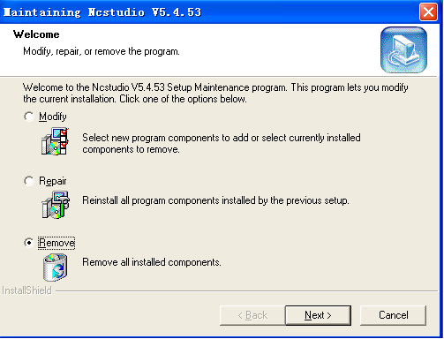
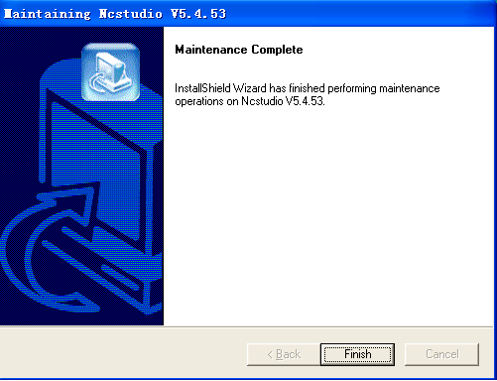
After clicked the “complete” button, whole unloading process ended.
Attention:
The unloading process above basis different edition different, the content gave supplies only the reference
2.5 the Connection of Ncstudio™ Control-card and driver system
The signal of the Ncstudio™ mechanical movement control through the control-card which inserted in the extend plot, realizes the communication between the Ncstudio™ software system and the feed motor-drivers system which was installed in the electricity gas tank of the engine bed.
Before the connection of the Ncstudio™ control-card and motor-driven system, you should installed first the engine bed and the electricity gas tank, uses the special electric cable connect the plug on the control-card to the corresponding plug on the electricity gas tank, Then, the connection of the control-card and the motor-driven system have completed.
How connect the card and the electrical gas system, please refer to the booklet of the card idiographic edition.
The different edition possible work with the different model, the function provided is different also.

3.Ncstudio™ Basic concept
3.1 Operation pattern and status
Operation pattern
The operation of the manager to the engine bed is in one of following several kinds of operation patterns at any time, the understanding to the operation pattern is extremely necessary to manager's correct operation.
Auto pattern
In the automatic operation pattern, the engine bed brings the movement with the processing procedure that have prepared beforehand. Therefore the system had loaded the processing procedure in the automatic pattern.
Spot pattern
It is one kind of the Manual operation pattern. In the spot pattern, the manager operates the equipment through the manual, the control engine bed like the computer keyboard, the hand-hold box, the hand operated pulse generator and so on. The manager sends out the movement signal through these equipment when presses down the manual button, the engine bed continue moving up to the loss of signal when the manager undo the manual button.
Increase pattern
It is one kind of Manual operation pattern, in the increase pattern, the manager is also through the manual operates the equipment, the control engine bed like the computer keyboard, the hand-hold box, the hand operated pulse generator and so on. Differ from the spot move is, the manager pressed key one time, also from presses down to undo, engine bed moved determinate distance. In other words, through the increase way, the manager may control precisely the displacement mete of the engine bed.
MDI pattern
It is one kind of Manual operation pattern, in this pattern the manager may control engine bed directly through input the G instruction. When the system carries out some procedure operation in certain situations (like returns to work origin), can the status can also change to the MDI pattern automatically. But this can’t affect the manager’s use.
Operation status
In each kind of operation pattern, also may divide into several kind of operating statuses, we can say that both the operation pattern and the operating status have determined completely the status of the engine bed.
Idle status
This is the most common status, the engine bed has not the output action currently and prepares to accept the new duty as necessary simultaneity and starts the new movement in the status.
Locked status
The locked status belongs to interior status, generally indicates to appear in the present status switching. Therefore the manager cannot contact in the ordinary complexion.
Stop urgent status
This is one kind unusual status. When the engine bed exist the hardware trouble or the manager press down the “stop urgent” button, the system enters this status and carries out the protection movement set in advance, like shut down spindle electrical machinery, the cooling pump and so on, in this status, the engine bed are locked also and cannot carries out any new action. After the manager eliminates hardware fault or removes the switch of stop urgent, the system execute the “restoration” operation that the engine bed restores to the “idle” status.
Movement status
The system enters the movement status when the engine bed is executing the action.
Pause status
When engine bed is moving, if the manager executes the “operation| pause” order, or the system analyzes to M01 (waiting instruction), then the system enters the pause status and waiting for the further input the manager’s, The manager may continues to carrying out through the execution of the “operation| start” order and may carry out the “stop” or “restoration” instruction to stops the current operation so that the system entered the “idle” status.

3.2 Engine bed coordinate system
The coordinate system is nomenclature that described the engine bed movement. In order to unify expression, the standard coordinate system uses the coordinate system the law of right hand. The following chart shows
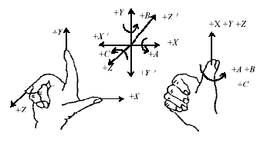
In the milling class engine bed, the direction of the engine bed ‘s coordinate axis is decided by both the type of the engine bed and the layout of each parts, speaking of the milling machine, the basic coordinate axis is X, Y, Z:
1) Z axis and spindle in line, the direction which cutting tool far away the workpiece is the positive direction (+Z);
2) X axis plumb Z axis and is parallel to the surface workpiece attire card surface, if it is the click column milling machine, then face the spindle of the tools looks to the column direction, its right movement direction is X axis positive direction (+X);
3) The axis of Y together composed the coordinates system followed right-hand rule with axis of X and the axis of Z.
Machinery coordinate system
The mechanical coordinate system is a set of coordinates fixed right-hand, its coordinates origin is relative to some stationary position in engine bed throughout. Therefore, any spot in spatial all may uses the mechanical coordinate system to determine only at any time.
Whole support for the mechanical coordinate system needed the function that the engine bed returns to the mechanical reference point, otherwise, the concept of the mechanical coordinate system manifests in the software only.
Workpiece coordinate system
When using the engine bed processes each kind of workpiece, we more uses the workpiece coordinate system. Usually, when workpiece is processing, we describe some processing position to be always relative to some spot on the workpiece, but the nip install position of the workpiece in the engine bed to be relative to the mechanical origin is changed frequently, Therefore it is necessary to introduces a set of the coordinates system in the workpiece processing convenient, this is the workpiece coordinate system. The workpiece coordinate system is a set of right-handed coordinate system also, its origin is confirmed relative to some spot in the workpiece, it may fluctuate relative to the mechanical origin coordinates.

4. Ncstudio™ Operation contact surface

First, installed the Ncstudio™ software system to the Windows according to the steps introduced in front, after this, double click the Ncstudio quick way on tabletop might move to the system. The Ncstudio™ numerical control system’s host operation interface the chart shows.
The Ncstudio™ interface is composed of the title bar, the menu bar, the toolbar, the status bar and some function windows. The following chart shows:
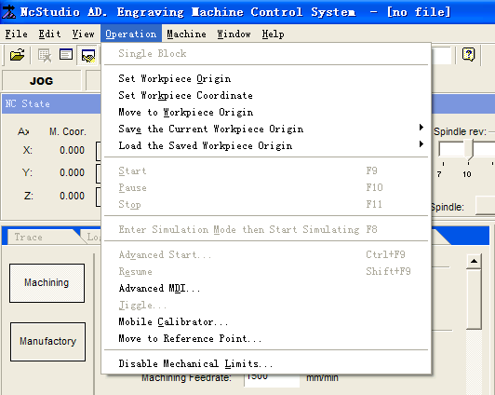 The function window divides into three sections, include:
First section: the Numerical control status window;
Second section: the trace, the log, the file manager, the parameter, the editor, I/O status windows;
Third section: Automatic window, manual window
4.1 Title bar
the most upper of the Ncstudio™ software interface is the title bar that was used to display the software name and the name of the processing procedure loaded, the title bar’s color was used to indicate the windows corresponding whether is activated
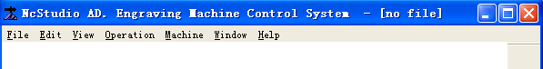
Attention:
In the Windows system, the active window and the non-active window are the extremely important concepts. The active window is the window current which accepts the keyboard inputting, at any time, the system has window active only, the others belong to the non-activity window.
Please distinguish the difference between the active window and the non-active window of the title bar’s color. In the Windows’s default establish, the active window title bar’s color is blue color, But the non-active window title bar is gray.
The left icon of the title bar is the system menu frame, it is used to open the window control menu, clicks this icon with the mouse or presses the quick key “the ALT +space” will pop-up the system menu.
This menu is used to control the size and the position of the windows, like revert, move, close, max, min and so on. The right of the title bar has 3 control buttons that are the minimum button, the reductive button, and the maximize button. These buttons used in establishing of the window size fast. The detailed operating mode refers to the MS Windows help online
Moreover, every sub-window has the title bar corresponded, both of the active sub-window and the non-active sub-window are distinguished through the title bar color of the sub-window. Please refers to description of each section:
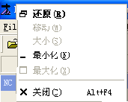
Note:
The active sub-window of three windows area may through the ESC key to switch.
4.2 Menu bar
The below of the title bar was the menu bar, the menu bar contains many pull the under-pull menu hided, like the chart showed
Each the under-pull menu to be composed by many menu items; Each menu item corresponds the function, the action or the status of some procedure assigned, Through chooses certain menu item assigned to carry out the function or the movement corresponding, or changes the status setting. Choose menu item may be completed with the mouse, also may completed through the keyboard.
Mouse operation
First, Using the mouse’s left key clicks menu bar of the main menu, after pop-up the under-pull menu, Clicks the menu item chose with the mouse’s left key.
Keyboard operation
Pressing down the ALT key and the hot-key letter chose of the menu at the same time (having under-lineation letter, like “document (F)” use the “ALT +F” combines key to choose). After selected certain menu, it will appears the under-pull sub-menu corresponding.
Quick-key operation
In the under-pull sub-menu, the right of some menu option is opposite to the quick-key corresponding, For example: The quick key which the “start (S)…” option of the “Operate (O)” menu is “F9”, indicated that pressing the quick key carries out the menu order directly, like this might reduce the trouble that enters the multi-layered menu.
Behind some menu option has three dot symbols (for example “open and load (O)…”) that indicated pop-ups a dialog box automatic after chose this item, If certain menu option in under-pull sub-menu shows gray, then it express these options can’t been chose under the current status.
In addition, clicking the mouse’s right key will pop-ups the quick menu in the different position of the window, and might carry out the frequent execution order which be most related to current position.

4.3 toolbar
Below of the Menu bar is a toolbar that was composed by some certain operating buttons, these are corresponding certain menu order or the option function separately. We can directly clicking the buttons with the mouse to complete function assigned.
The toolbar button has predigest manager's operating process greatly, and caused the operating process visualization, and the tedious command line sequence no longer.
4.4 Numerical control information bar
The numerical control information bar is located under the toolbar, revealed the numerical control status currently and some the warning information.
4.5 status bar
The most bottom of the screen is the status bar, like the chart shows:

Prompt character area: It gives the current operation or chooses the information the order prompted
Date and time instruction: it shows the current date and the time information.
Keyboard lock instruction: it instructs the keyboard capital letter lock, the numeric lock and the trundle lock current status.
4.6 Numerical control status window
The coordinates show window located the up of the screen, reveals the current position of the spindle (cutting tool), the feed rate and the feed times-percentage adjustment currently.
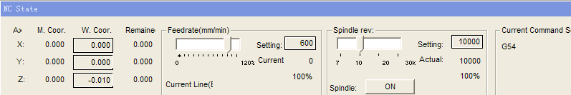
Attention:
This window shows the content is dissimilarity according as the different board card’s establishment and the different manager demand, here gives the content supplies only the reference.
Processing status and time information
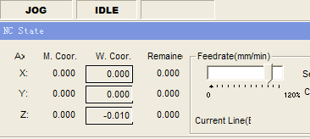
The title bar of the numerical control status window also shows some status information. On the chart shows, for example in the system simulation, the title bar shows the “simulation pattern” typeface, Meanwhile shows execution time estimated in the right of the title bar (use 100% feedrate Calculate). When actual processing, the right side shows the actual processing time.
Current position
The Ncstudio™ shows two sets of coordinates systems at the same time for describes all kinds of position convenient: the Mechanical coordinate system and the workpiece coordinate system. The Ncstudio™ have provided the rich function to support these two sets of coordinate systems, the manager may looks over these two sets of coordinate systems simultaneously and switching free in two sets of coordinate systems, as well as setting the relative biases flexible both of two sets of coordinate systems.
After the manager have carried out the operation of returning to the reference point already, in front of each axis name could appears the “the mechanical coordinates are effective” symbol. Like the chart shows
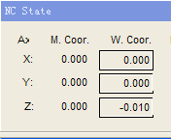

The system has provided the convenient setting and the method of modify the workpiece origin, setting the current point to the workpiece origin, as well as the relative position of the click axis clears zero, Only must moving the cursor to this axis coordinates show area, then clicks the mouse’s left key, thus may see that this axis’s coordinates become 0. If you want the current positions of 3 axes are established to 0 completely, only clicks in each coordinates area.
Prompt:
Another method which resetting the current point of the workpiece coordinates completely is chooses the "operate (O)| Set workpiece origin…” menu or choose the equal toolbar button If need establish directly.
Feed rate
In feed rate area shows the information like setting velocity, velocity percentage, current line (section) and so on. Also may revises the velocity value set and the feed times-percentage.
Feed times-percentage slide rod: hauling the slide rod and adjusting the rate of movement in the scope (0~120%) currently. The rate of feed times-percentage demonstrated by the percentage format.
Setting value: the setting value of Feed rate is also the value the F parameter of the G instruction gave.
Actual value: The feed rate’s instantaneous value, it may change along with the setting value, the current velocityup or deceleration status and the feed rate changes.
Current line (section) number: shows the section number or row number that is carrying out presently. If the current processing procedure contains the information of the section number, then shows the section number, the display format is: N?????. If the processing procedure does not contain the information of the section number , then shows the row’s information, the display format is: L?????
When the system is free, click the setting value, then pop-ups the velocity setting dialog box. When the system located auto status, the dialog box had pop-up used to the setting of the default velocity auto moving, like the chart shows
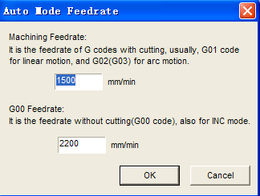

When the system in the manual way, the pop-uping dialog box uses to establishing the velocity of the manual movement, like the chart shows
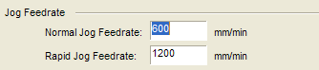

Needs to point out, the hypothetic movement in here and the hypothesis in the “parameter” bar of the parameter window is same.
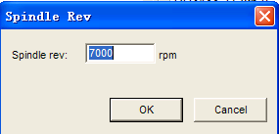

Engine bed control
The last fence of the window is the engine bed’s controlling which used to control the movement of the engine bed’s spindle, the cooling and so on. On the one hand these buttons were operated directly by the manager, on the other hand reflects also the engine bed’s status, the movement of the spindle, the cooling may carry out also in processing, but the system gives also some protective prompt, for example: closing the spindle in processing, the system can appears the following prompt.
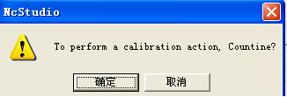

The manager may operates these buttons by the mouse or the keyboard, when ON button is in pressing down, occur the corresponding movement, for example: The chart express the spindle stops revolving, but the cooling opening.
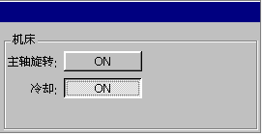
4.7 Automatic window
The automatic operation window shows the processing procedure document opening current, the Ncstudio™ supports two kind of processing procedure format at present: G instruction format and HP PLT format. The manager may examines the current processing procedure through this window.
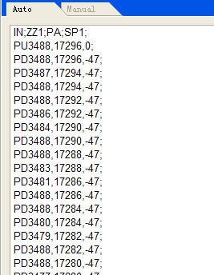

In the window pressing the mouse’s right key, the system pop-ups the context menu, following chart:
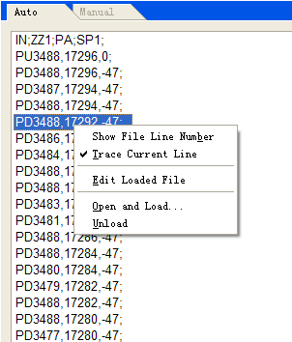
These menu items synthesized with the regular operation related automatic operation, these menu items can be found also in the standard menu at the same time, this has facilitated the manager's keyboard operation. In which: the “show the processing procedure row” and the “ track current line” menu item may be found in the “view” menu; The surplus three items may be found in the “filet” menu. The explanation about theirs refers to 5.1 and 5.2.
Because the document window is located the function window area of the host window, the methods that the manager needs to switch in several windows, activation document window is:
The menu way
Choosing “window (W)| show automatic window (A);
The quick-key way
Pressing the “Ctrl +1” key to active the window;
Prompt:
The processing procedure showed in this window only supplies the examination, cannot carry on editing and revising. If needs to edit this procedure, please carry out “file| edit loaded file”; If edit certain procedure or the document merely, please carry out “file| Open and edit…”
4.8 Manual window
The manual window provides an interactive operating environment for the manager by the manual operation engine bed
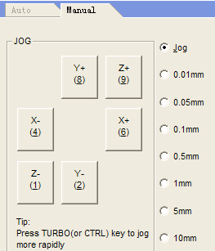
Because the manual window is located the function window area of the host window, the methods that the manager needs to switch in several windows, activation manual window are:
The menu way
Choosing “window (W)| show manual window (M)”;

The quick- key way
Pressing the “Ctrl +2” key to active the window
The manual button area in the window Contains six manual buttons, corresponds X, Y, the Z axis positive and negative direction separately.
The manual operation engine bed has two ways: continual spot moves and increase step-by-steps, below introduced separately.
The continual spot move
The way of continual spot moves， When manual window is current active window, pressing down numeric keyboard on the small keyboard corresponds. Engine bed moves when the key in pressing down status,; the engine bed stops moving when loosens the pressed key,
Attention:
The manual window must be the current active window. This may see through the title bar color of the manual window.
When manual function in activate status does not considering the numeric lock status.
The track window by G00 instruction color shows the trace when the executive point Moving.
The way of increase step-by-steps
This is similar with manual way, the way of the increase step-by-steps (i.e. increase way, or step-by-steps way) is another kind of the engine bed mode of the manual operation, the difference with the continual spot moving is that the increase way can control the feeding distance of the engine bed’s motive axis precisely.
The manager may carries out the increase feed operation through the interactive mutual surface with the mouse and the keyboard, also may carries out this operation through the manual operation board or the operation box. Triggering the manual button every time, the axis corresponding moves the length of step assigned.
You must have established the appropriate length of step before using this operation machine way, using revised the length of spot and setting the feed distance of every time spot moves.
The board way
When the spot way is the active window current, using the direction key to increase/decrease the length of the step, then we can notices the change of the spot length.
The mouse way
Using the mouse clicks the step button directly.
Attention:
You should be avoid to the spot length of the axis of Z set too big at lest machine shatter for the wrong operation.
We can operate the engine bed with the buttons of the board, the mouse and the manual control board after setting the length of step proper.
The board way
When the manual window is the active window current, pressing down the number one time, the button will be sprang one time, pressing down the space key one time, the button which process of input focus current will be sprang
Attention:
Because the system needs some time in executing the spot instruction every time, so clicking frequently leads to the system prompt of this error information: “the system busy, the current operation inefficacy”
The Increase/decrease depth
Using the +/- key of the small keyboard with the number key to increase and decrease the depth.
4.9 trace window
In the engine bed executing processing procedure or simulating, the trace window can track the processing path by the real-time way. The three-dimensional real time display function of the track path can examine the cutting tool’s way more intuitional for the manager, and guarantees the processing procedure not to make a mistake.
The track window uses the three-dimensional view pattern. Choosing the “view| Attribute…”menu carries on the personalized establishment. Refers to 5.2.

Three-dimensional view pattern
In the three-dimensional tracking pattern, the system has provided the rich operation method to for the manager convenient from the different angle, in proper scaling examining the graph.
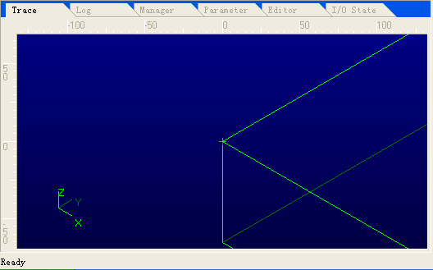
The scaling function
Using three ways all of the menu, the keyboard and the mouse added the keyboard realize and track the path graph’s zoom in and zoom out.

The menu way
Choosing “view (V)| Zoom ratio(R)…”Establishes the appropriates the proper scaling..

The keyboard way
First, you should activate this window to the activate window, chooses the addition/subtraction (“+”,”-”) key in the small keyboard realizes the zoom.

Attention:
The addition and subtraction (“+””-”) key in the main keyboard is invalid.

The mouse add the keyboard way
Moving the mouse to the show area, when the mouse showed is , clicks the left key of the mouse to enlarge the graph; While the mouse showed is , clicks the left key of the mouse to reduce the graph. Pressing down the CTRL key, the mouse showed switches between the pattern and the pattern.
Prompt:
Carrying on the graph zoom with the mouse, in the mouse clicking process, do not moving the mouse; or become the movement operating.
The move function
The mouse way
Realizing the movement operation of the track graph with the left key of the mouse dragging operation. Specifically: Moves the mouse to the show area, then the mouse shows or , Presses down the mouse left key, and moves the mouse slightly, then the mouse finger turns the status The status, continues to drive the mouse, then loosens the mouse left key, completes the whole track graph the motion movement.
Prompt:
Please practice several time, you can discover this operation with this method convenient!

The keyboard way
Completed four direction keys track graph with the keyboard on four direction keys the motion operation.
The revolve function
The revolving operation only can (i.e. “the ALT direction key”) be completed with the keyboard operation. When Pressing the ALT key presses down the direction key can to realize the revolving operation of the track graph.
The system has provided the viewing direction in common which can switch with the numeric keyboard in the small keyboard rapidly.
1 Southwest direction view
2 Looks up chart
3 southeast direction view
4 left view
5 front view
6right view
7 northwest direction view
8 Vertical view
9 northeast direction view
The clear function
When the processing time to be very long, the simulation graph becomes extremely complexity, the temporary file used in records the processes trace to be also big increasingly, when the simulation graph was redrawing, moving or revolving operation, extremely time-consuming. By now the manager needed to clear the track picture.
Clearing the track picture have many kinds of methods, it can be completed with the menu, the toolbar button, the quick key and the keyboard operation.
The menu or toolbar way
Choosing the “view (V)| clear view (C)” menu or choosing the toolbar button corresponding.
The quick-key way
In any time, pressing down the “CTRL+DEL” key to realize to clear the track picture.
The keyboard way
Pressing the DEL key when the track window is the active window currently.
The context menu
Clicking the mouse’s right key in the window, pop-ups the context menu. The concrete function on the menu item had introduced in this already, here give unnecessary detail no longer.
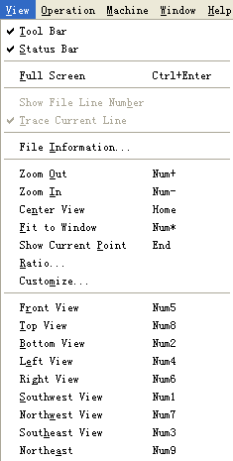

Establish personal parameter
Establishing on the personal parameter with the “parameter” dialog-box establishes the custom-made on the system in the view. Mainly aiming at the personal establishment on the track window. Realizing the track pattern and the definition on color.
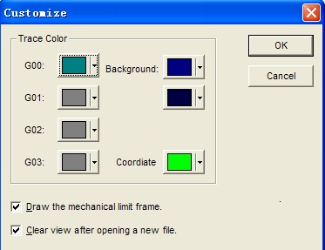
Track color: In the track window, each kind color of different show element may be disposed separately. Mainly includes:
The G00 instruction color: This color denotes the color in revealing the G00 instruction trace.
The G01 instruction color: This color denotes the color in revealing the G01 instruction trace.
The G02 instruction color: This color denotes the color in revealing the G02 instruction trace.
The G03 instruction color: This color denotes the color in revealing the G03 instruction trace.
The background color: tracking the window background color, here has two kinds of color, the manager may designates the different color, realizes to gradual change between two kind of color.
The coordinates color: This color denotes the color on drawing up the hint coordinates in the window
Moreover: the manual and the spot path is with the G00 the color to demonstrate.
The manager click-shots the color and choose the button, the system pop-ups the under-pulling color choice frame, like the chart shows
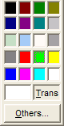

Prompt:
If the color chose is transparent, then hides the instruction trace in corresponding.
However, establishing the background transparent is not a great idea, because this often causes that the window does not to be refurbished natural.

4.10 The log window
The system log window records important operation and occurred event of the manager, Not only looking through the log information which has occurred since this startup, but also looking back the historical information records which occurred once with this window. You can discover the system log information more and more helpful to you along with the using experience enriches gradually.
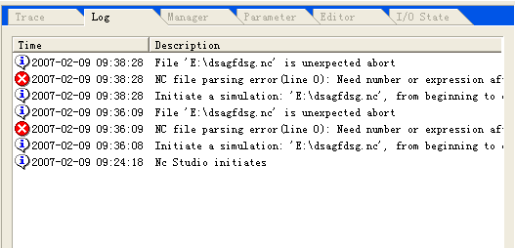 The log information of the system records at present includes:
The startup and closure of the system
The startup and finished the information on the Automatic processing
The changing on the work coordinates
The system warning information
The others system information
Attention:
Remembering to clear up the log regular, or it can be affect the performance and the response time on the system because the system log record document too big.
4.11 the file manager window

The Ncstudio™ has provided the management ability integrated on processing procedure, caused the manager to be possible to manages the processing procedure conveniently. Including:
Founding the new processing procedure
Edition the processing procedure
Deletion the processing procedure
Processing the filename change
Loading the processing procedure
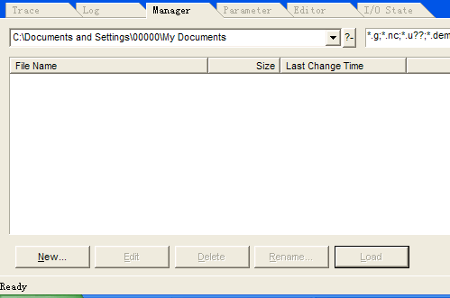

The management window of the procedure may uses the folder the manager defined and user-defined the document extension. These setting also can restore after the manager closed down.
4.12 the parameter window
The Ncstudio™ have the abundant processing parameter, which causes the system was capable of completed each kind of task, this shows only some processing parameter in common, and some parameter isn’t referred for the manager, so the system interface has not showed, like this also avoided the manager feels puzzle for the parameter system excessively complexity.
The system parameter including two kinds: The processing parameter and the manufacturer parameter, the below explains each parameter in detail.
Machining
The Ncstudio™ has multitudinous processing parameter, enables the systemic capability exerts to the most according to the concrete machinery and the electrical status, In the “parameter” window listed is only some commonly processing parameter, and some parameter isn’t referred for the manager, so the system interface has not showed, like this also avoided the manager feels puzzle for the parameter system excessively complexity.
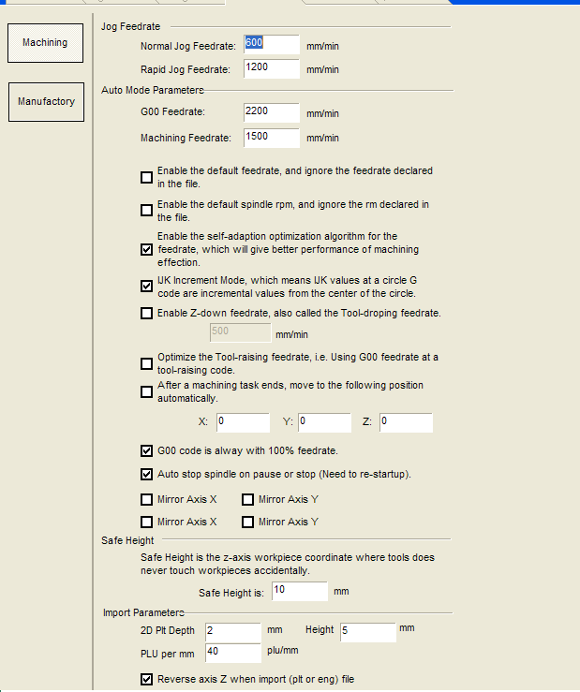
The Manual velocity: Including the manual high velocity and the manual low velocity, both of values use to control the movement velocity about the manager in the “spot” pattern.
The manual low velocity refers the movement velocity in pressing down the manual direction key only;
The manual high velocity refers the movement velocity in pressing down the manual direction key simultaneous.
These two values also were established directly in the numerical control status window. See 4.6
Automatic parameter:
The air-move rate: the movement velocity of the G00 instruction
The processing rate: the interpolation rate of the G01.G02.G03 processing instruction and so on.
These two values control the rate in the automatic way movement, if the processing procedure in the automatic pattern or the MDI instruction has not assigned the velocity, then moving the rate established in here.
Attention:
The movement rate of the increase way is the air-move rate,
These two values also may be established directly in the numerical control status window. See 4.6
Using the default velocity: Whether gives up the velocity established in the processing procedure, uses the system default velocity established above.
Using the default revolving velocity: indicating the system whether gives up the revolving velocity established on the spindle in the processing procedure, uses the system default revolving velocity established by man.

The Velocity auto-adapted optimization: Whether allows the system carrying out optimization depend on the connection trait
The IJK increase pattern: The center of circle programs (IJK) whether is the increase pattern, certain IJK value which the arc programming used by the back-processing procedure made is the increase value, About this point, please refer to the back-processing procedure explanation in corresponding.
Using fall-tool velocity on the Z direction: Whether uses the specific velocity on falling the tool when the Z detection plumbs downward movement
Optimizes the raise-tool velocity on the Z direction: Whether uses the G00 velocity to raise the tool on the Z direction when the Z detection plumbs upward movement.
The air-move (G00) instruction used the 100% feedrate fixed: This parameter is an option. The indicating system whether neglects the influence on the feed rate in carrying out the air-move instruction. Then it does not affect the air-move velocity works as the percentage changes.
When in pause or closure, stops the spindle (needs to restart): supposes after the processing procedure paused in midway or the processing had ended, whether automatic stop the spindle running.
The mirror image on the X: Establishes X to carry on the mirror image.
The mirror image on the Y: Establishes the Y to carry on the mirror image.
The parameter on the exchange-tool position:
Using the exchanging-tool position: If hoped the tool after completed the processing returns to certain position automatically, please choose this option. The other exchanging-tool position parameter has an effect only in using the exchange-tool position.
The mechanical coordinates X, Y, Z of the exchanging-tool position: setting the mechanical coordinates of certain exchange-tool position (attention: it Is not the workpiece coordinates!).

The backing-tool parameter:
The backing-tool spot: carrying out the continual movement of the workpiece origin or the break point, the tool lifts the height (relate to the workpiece origin).
The Document input parameter:
The depth of 2D PLT processing: setting the tool depth on the PLT document processing loaded.
The height of raising-tool: setting the height of raising-tool when the PLT document processing
PLT unit millimeter: Establishes the value of the PLT unit.
The reverse direction of the Z axis: Establishes whether uses the reverse function of the Z axis. This system defaults that the Z axis go upwards is positive.

The revolving axis parameter:
The axis is the revolving axis: If the Y axis is a revolving axis, chooses this option, the other revolving axis parameter only may be established when the revolving axis effective.
The rotating axis uses the angle (degree): If the revolving axis on the solid of revolution processing document takes the angle as a unit, chooses this item.
The rotating axis uses the length (millimeter): If the revolving axis on the solid of revolution processing document takes the length in the processing surface as a unit, chooses this item. By now needs to input the revolving radius in the workpiece.
Parameter
The manager cannot contact “parameter” in commonly circumstances, so you may jumps over this section. The general consumer non-authorized also prompts inputting of the password before the system enters the “parameter”. This only is prevent the manager revised these important parameters occasionally, and causes the system to appear the failure.
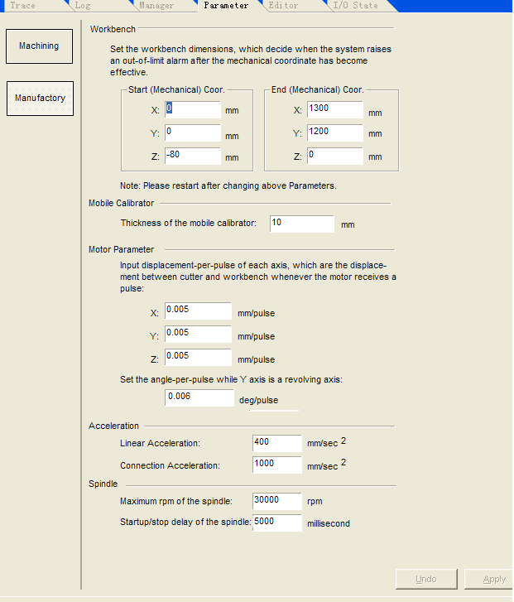
The mechanical limit frame:
Indicating the effective processing scope of the workbench, here uses in the mechanical coordinates, attention, general Z axis’ mechanical zero in above, therefore, the Z axis’ effective scope is smaller than the zero in generally.
According to the position on the mechanical limit switch, confirmed the actual frame has the help extremely to protect the engine bed. After established the workbench frame reasonably, if the engine bed’s movement surpasses this scope, then the system prompts the soft limited warning, At this time has an effect is not the real limit switch, but the software basis the result that both the mechanical coordinates and the workbench frame compared, but cannot brings the damage because of hitting the limit switch or the hard limit.
Attention:
This value have been established already in exwork, please do not revise arbitrarily! If must be revised, please examine carefully.
The calibrator parameter:
The calibrator thickness: Please surveyed the thickness on the calibrator accurate and filled in here. Attention: This value already has been established generally in exwork, please do not revise arbitrarily.
Fixing the mechanical coordinates of the calibrator: when using the working of calibrator fixed, needs to assign the mechanical coordinates on the calibrator, please fills in this value accurately, assured the calibration was success.
The parameter of the electrical machine:
The step of pulse: Indicates the smallest displacement quantity which the control-card can disposed, in the step-by-steps system, it corresponds to one step-by-step pulse generally, and according to the transmission relations, takes the angular displacement of the step-by-steps pulse to transform the line quantity.
The velocity of the startup: This parameter corresponds the frequency of the startup on the electrical machinery.

Acceleration: The system uses two acceleration parameters to determine the accelerating ability of the movement:
The acceleration of click axle: using to describe the capability of addition or deceleration about click feed-axis.
The acceleration of curve: using to describe the capability of addition or deceleration when many feed-axis in status of the linkage.
Warning:
The parameter has adjusted in common when in exwork. Established this parameter to be able not appropriate to cause the processing error, even causes the engine bed damages.
Spindle parameter
This group of parameter uses in controlling the spindle behavior. The concrete target has two: The spindle high velocity and the start up (stop) delay of the spindle.
High revolving velocity of spindle.
When the system uses the manipulative way with the continual revolving velocity, the biggest of simulant output corresponds to the revolving velocity of the spindle
The spindle starts (stop) the time.
When the procedure starts up and stops, if using the function of automatic open and stop in the spindle, because the spindle’s opens and stops needs certain time, needs to certain time to delay, this parameter uses in establishing the time to delay.
The pulse generator by the hand operated:
The newly Ncstudio edition supports the pulse generator by the hand operated. If prepares to using this function, please established this group of parameters correctly. The groups of parameters have two: Supports the pulse generator by the hand operated and strict to count of the pulse generator by the hand operated.
Supports the pulse generator by the hand operated: When prepares to use the pulse generator by the hand operated, must cause this option to be effective. Then the I/O of the control-card was defined according to the way of the pulse generator by the hand operated.
Strict to count of the pulse generator by the hand operated: In this case, the moving distance of the engine bed counts corresponding to the hand-wheel, but in case of the hand-wheel revolved too quick, even if the hand-wheel stops, the engine bed still moving with a long time. When does not use this parameter, the system has the quick response-time to the hand-wheel revolving, but, when rotates too quickly, it possibly creates the distance of the engine bed moving does not accord with the distance of the hand-wheel rotating
4.13 “editor” window
The upper of the editing window is the procedural filename edited. Below is a standard editing window belongs to the Windows style.
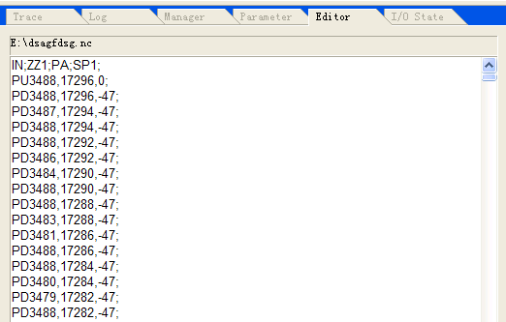

This editing ability of the window is big out and away compared to the “notepad” of the “adjunct” procedure of the Windows scheme, this editing window may edits the processing procedure which size is surpasses 1000M (also is 1G) byte, thus satisfied to the request in editing complex processing procedure willfully.
4.14 I/O state window
The I/O status window displays the current reflection of system, this is helpful to the systemic surveillance and the blooey diagnosis
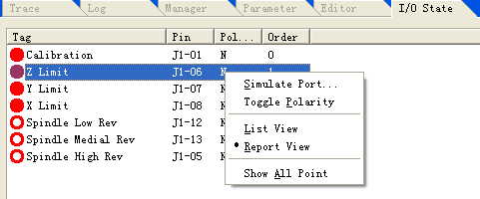
Attention:
This window showed the content is difference according to the different establishment of the board card and the different manager demand, here gives the content and supplies the reference only.

5.The menu system
5.1 “File” menu
In the “files” menu contains carries on the injunctive operation to the document order option
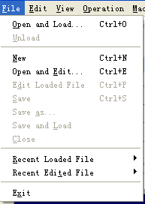

The two items in first of this under-pulling menu use to “load” and “unload” in the procedure document. Here the function of loading and unloading were related with the automatic processing, indicates the procedure document to load to the buffer of the numerical control procedure explaining, along with unloading from it, this program displays in the automatic window after loading.
The seven items in middle of the menu use to edit in the procedure document. The Document opened by the editing function shows on the editing window. Please attentions the difference with “load” and “unload” function.
Open and load
The “Open and load” item can be executed fast with the quick-key of “CTRL +O”.
This menu uses to open the processing procedure document that have had or saved in the floppy disk, and loads it to the buffer of the numerical control procedure explaining, then the engine the numerical control procedure explaining may explain the data in the buffer by a line, and transmits the processing instruction produced to the numerical control card. This is the realization of the processing process.
Chooses this menu and pop-ups the “open” dialog box, like the chart shows:
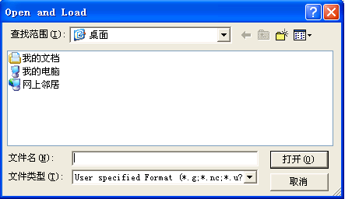

The manager chooses from the disk driver, the way as well as the filename, which contains the file that should open. After opens the processing procedure, the manager may see this procedure in the automatic window.
Moreover, after opens the processing procedure, the manager can notices the title bar in the host window of the system have changed:
The filename of the processing procedure opened located after the filename; The document window displayed the content in opening document currently; Some menu item which have been forbidden concerned the automatic process is efficiency to use, For example: The “start” menu item of the “operation” menu, indicated the manager may carry on the automatic processing operation.
In the old Ncstudio™ edition, once the processing procedure was loaded to the system, this document would in the running status, this meant that others procedures cannot carry on the revision to this document (but it can executes the “read” operation), therefore, the manager must closes this document in the Ncstudio™ system if the manager want to revise this document. This limit obtains the radical improvement in the new edition.
New edition, also is the later of the 5.0 edition, after loads the procedure document to the buffer of the numerical control procedure explaining, the later visitation based on this buffer, is separated from with the actual document, thus realized that the manager might carry on the revision to the document in after the processing procedure document has been loaded to the system, but the revision in this time with the document in processing is having nothing to do; If needs to apply these revisions, you may loads the procedure document to the system.
From the 5.4.33 editions, increasing the support for the processing document (*.eng) of the extractive-carve.
Unload
After loaded the processing procedure to the system, the manager may chooses the closure function, closes the document that have loaded to the buffer of the numerical control procedure explaining.
Attention:
If the current document is processing, then cannot close it.
New
Choosing this function, the system opens an editing window for the manager edit the new document, the manager saves this document in the editing process at any moment.
Open and edit
This menu uses to open the processing procedure document that have had or saved in the floppy disk, and loads to the editing window. The manager may executes the edition function in the editing window.
Edit loaded file
This function loads the procedure document that has had in the buffer of the numerical control procedure explaining to the editing window in current. This menu item only was effective in the procedure document of the buffer of the numerical control procedure explaining.
Save
The function is storing the procedure document in the editing window to the computer. This function would educe the “save as” dialog-box if the current edition is the new document,
Save as
This function is that revising the name of the procedure document in the editing window in current and saving to the computer. Executing this functional procedure to pop-up the “save as” dialog-box, the manager assigns the way and the filename in among, chooses the “save” button, then the document saved by new filename; chooses the “cancel” button, then cancels this saving movement.
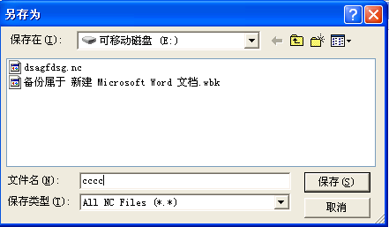
Save and load
This function is the combination of the “save” and the “open and load”.
First is the same with the saving function, saving the procedure document in the editing window to the computer in current. Then, loading the procedure document saved to the buffer of the numerical control procedure explaining of the system.
Close
This menu closes the procedure document editing presently.
Recent loaded file
This menu item can opens a new sub-menu, the sub-menu showed the processing filename edited recently, if the manager want to load these documents again, please clicks the filename directly, then might edit these documents fast.
Recent edited file
This is similar to the last menu item, this menu item can open a new sub-menu, the sub-menu showed the processing filename edited recently, if the manager want to load these documents again, please clicks the filename directly, then might edit these documents fast.

Exit
Choosing this option, the manager may closes the numerical control system of the Ncstudio™. In this time, if the manager has the procedure document editing and has not saved, will pop-ups the dialog box to prompt whether to save the document, if needing save then clicks the “yes” choice, if not then clicks the “not” choice, if don’t exiting then clicks the “cancel” choice.
If the manager is processing automatically, the system will prompts the manager to finished the processing duty in current, then exits from the system.
5.2 “edit” menu

The “edit” menu contains the menu item in editing window, this menu item will be difference along with the difference of the current active window in the second window area. This is because that these windows possibly contain some the specific editing function.
The next chart is the editing window in activation of the systemic parameter window, the I/O status window and the procedure edit window. Then, the values of the menu item contain some most basic menu item.
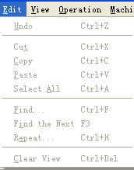
The next chart is the editing menu when the track window is in activation.
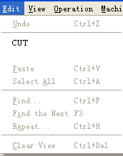
The next chart is editing menu time the system log window is in activation.

5.3 “view” menu
The “view” menu contains the injunctive option that using to adjust the content showed in the main window.
Some of these menu items can be difference along with the difference in the main window. A menu like on chart all has which in all situations shows.
Tool bar
If the toolbar has opened, then chooses the “toolbar” menu item to close the toolbar. If the toolbar has closed, then chooses the “toolbar” menu item to open the toolbar.

Status bar
If the “status bar” has opened, then chooses the option of the status bar to close the status bar. If the status bar has closed, then chooses the “status bar” menu item to open the status bar.

Full screen
The full screen menu item uses in opening and restoring the “full screen” pattern. In the “full screen” pattern, the software surface will expand to the full screen, at the same time the menu and the title bar are hidden. Like the chart shows:
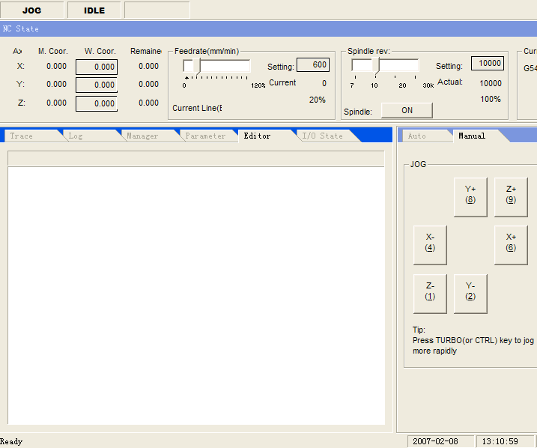
Attention:
Once entering the full screen pattern, the systemic menu is unable with the mouse to operate. Then exiting the full screen pattern with the quick key of the Ctrl and Enter.

Show file line number
This function shows or hides the line number of the processing procedure in the processing procedure window. This menu item only is effective when the processing procedure window is obvious.

Trace current line
This function instructed you to whether tracks and shows the current processing line in the processing procedure window. While this function has been selected, in the automatic processing process, the processing procedure window can rolls the content automatic, thus causes that the current processing is obvious in all course. Closed this function, the processing procedure window cannot rolls the content automatic.

File information..
Choosing this order, the software opens one the “file information” dialog box. Like the chart shows:
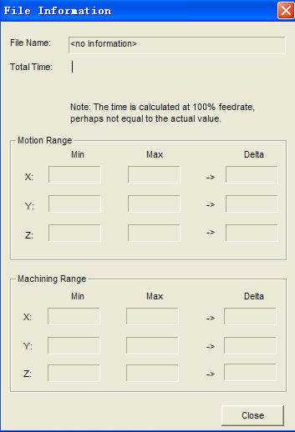

This dialog box showed the statistical information in the processes procedure of the automatic processing process. Like the processing time, the processing scope and so on. This function is union with simulation movement function, and understands each kind of information in the processing procedure fast and accurately.
5.4 “operation” menu
In the “operation” menu has realized each kind of operation to the engine bed. But not including the direct output (M function) to the feedrate and the control to the spindle, these functions were arranged in the “engine bed” menu.
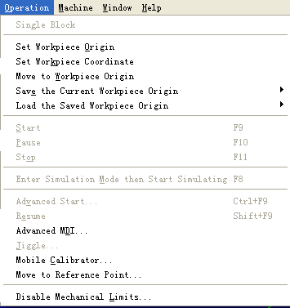
Click bar
This menu item enables and prohibits to the pattern of step process. Once the “click bar” is effective, then the processing procedure carrying out every sentence, then the manager must chooses the “start” menu item to execute the next sentence of the processing procedure, once the next sentence have carried out, the system will enters to the pause pattern.
Attention:
When the pattern of the velocity auto-adapted optimization is effective, in the step pattern, the tool position of the systemic pause is not necessarily in the target location assigned in each sentence precise, because this time the system has made the optimization for the processing velocity.
Set workpiece origin
Selecting the “set workpiece origin” menu item, namely setting the workpiece coordinates located at the current spot to zero, in fact this does not causes the actual position moving.
Set workpiece coordinate
This function enables the manager to sets the workpiece coordinates of the current spot conveniently. Through choosing this menu item, may changes the coordinates of the position in which the tool located currently. Chooses this menu item, the system pop-ups the “Set workpiece coordinate” dialog box, like the chart shows
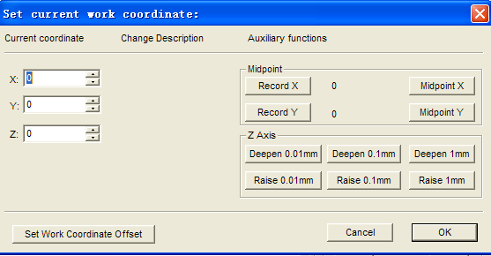

In the editing frame corresponding of the X, Y, Z axis inputs the Appropriate value, then the current position coordinates have changed already.

Attention:
In this process, the machinery in the engine bed has not carried out any movement. In fact, the system use to revise the position of the workpiece origin to adjust the spot coordinates currently.

Move to workpiece origin
The workpiece origin is the origin of the workpiece coordinates, which is set to the size and the programming of the workpiece, generally is the initial position of the workpiece processing. The workpiece origin may be chose by the programmer, it is determined by the “Set workpiece coordinate” with the mechanical origin.
Choosing the “Move to workpiece origin” option, the tool-point from the current position by the Z, X, Y order returns to the workpiece origin automatically.

Prompt:
In order to in the process of returning to the workpiece origin, the tool-point can passing the processing space safely, but cannot occur the accident because of touching the workpiece, the jig barriers and so on, therefore, carried on the way of returning to zero to the following optimization:
If the end-point coordinates are bigger than the start-point Z coordinates in Z direction, then first the Z axis to feeds to the end-point position of the Z axis individual, then uses the linkage with the X, Y axis, arrives the aim-point.
If the end-point coordinates are smaller than the start-point Z coordinates in Z direction, then using firstly the linkage with the X, Y axis to arrives the aim-point of the X, Y coordinates first, then, then the Z axis to feeds to the end-point position of the Z axis individual.
Because the end-point coordinates of Z axis often in the processing surface of the workpiece, in order to avoid to bump the workpiece surface or the tool-point processing surface, in fact, the Z axis doesn’t return to the zero, but in an offset above the zero. This value has set by “back-tool spot” in the processing parameter the “parameter” window.

Save workpiece origin
The manager may saves the workpiece origin using frequent to the scheduled value, in all may saves 10 groups of coordinates data. When the manager have established the workpiece origin in first time, if you would to located fast to this workpiece origin in later time, then might using this function to save this workpiece origin coordinate.

Read Current coordinate
Reading the coordinate scheduled of the workpiece origin, returns fast to the workpiece origin in reading supposes. After reading the workpiece origin, using the “move to workpiece origin” order to returns to the workpiece origin scheduled.
Start
This menu item contains two functions:
First: If certain processing procedure has loaded already, and the current systemic status was the “idle”, then chose this menu item, the engine bed would starts automatic from the first sentence of the processing procedure to carry out the process of the automatic processing. Once the processes is starting, the system enters the “auto |move” status; If the system occupies the simulation status, then executing the processing procedure in the simulation way.
Second: If the system occupied the “auto| pause” status, then chooses this menu item of the system to continue carrying out the automatic processing process from the pause status, enters the “auto |move” status, If the system occupied the simulation status, then executing the processing procedure in the simulation way.
Prompt:
The system has two ways to enter the “pause” status, the first way is that the system current occupies the “step” process; The second way was that the manager has chosen the“pause” function in the processing process.
Pause
In the automatic processing process, the “pause” function is effective. Chooses the “pause” menu item, the engine bed will pauses the processing and raises the tool, then enters the “auto| pause” status automatically. In this time only to choose the “ start” menu item as if continue carrying out the processing procedure.
If the system occupies the simulation status at present, then chooses the “pause” menu item, the system pauses the simulation and enters the “auto | pause” status. In this time only to choose the “ start” menu item as if continue to simulate.
Stop
In the automatic processing process, namely the system is in the “auto| move” status, the “stop” function is effective. This time choosing this menu item, the engine bed will stops processing and raises the tool, then ending the whole processing duty, The system enters the “auto |Idle” status. This is the method in which the system interrupts normal the processing procedure in the processing process.
But the “restore” function discussed in following is the using method of the unusual interrupt processing procedure in the non-conventional situation.
If the system occupies the simulation status at present, then chooses the “stop” menu item, the system stops to simulate and enters the “auto |Idle” status, but does not exit from the simulation status, the goal is that the manager analyses the simulating result. If the manager still executes the simulation operation, carrying out the “start”, the “advanced start”, the “break-point continue” menu and so on to continue to simulate.
Enter simulation mode then start
It is similar With the “start” menu item, if certain processing procedure has loaded already, and the current system status was the “idle”, then chose this menu item, the engine bed will starts to carry out the high velocity simulation automatically from processing procedure the first sentence. The simulation function is similar with the show function in the numerical control system, but surpasses to the show function.
The simulation has provided the simulating processing environment fast and lifelike for the manager.
Moving the processing procedure in the simulation way, the system does not drive the engine bed to make the mechanical electrical movement in corresponding, but merely shows the processing path of the tool high-speed in track window. In the simulation, the manager may understands the movement of which the engine bed must do in advance, prevented the fault in establishing the processing procedure to creates the engine bed was damaged, also understood other some of additional informations.
Once the simulation process starts, this menu item turns to the “stop simulation and exit simulation mode”, carrying out this function, the simulation will terminate immediately.
Advanced start
This function realized the function of which the procedure executes by jump the section.
Choosing this function, the system pop-ups the “execute (advance option)” dialog box, like the chart shows.
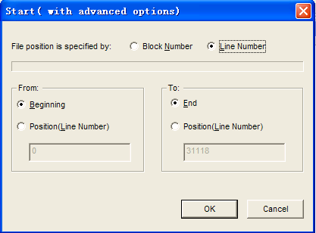
In the dialog box, the manager set the starting position and the ending position of the procedure in executing process, then clicks the “start” button, the engine bed carries out the segment assigned in whole processing procedure according to yours request.
This function also use in the simulating execution.
Resume
This menu function is a simple edition about the “advanced start” in fact, carries out this function, the system continue executing starts from the previous processing gap.
This function also use in the simulation execution.
Advanced MDI
Carrying out this menu item, the system pop-ups the “Advanced MDI” dialog box, like the chart shows
The following introduces each function separately:
Rectangle mill: like the upper chart shows, after the manager inputs some parameter needed, the system starts to carry out the mill function requesting.
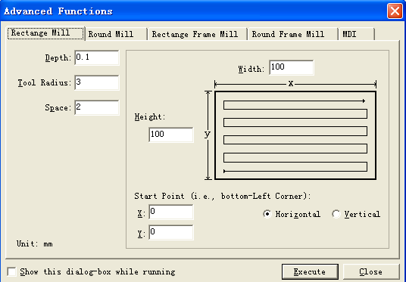
Circular mill: like the upper chart shows, after the manager inputs some parameter needed, the system starts to carry out the mill function requesting
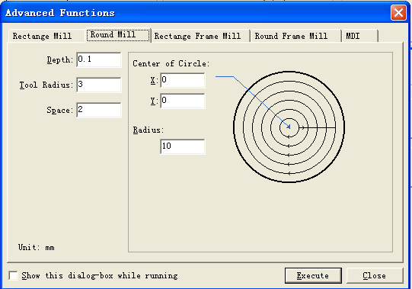
Rectangle frame mill: like the upper chart shows, after the manager inputs some parameter needed, the system starts to carry out the rectangle frame mill function requesting.
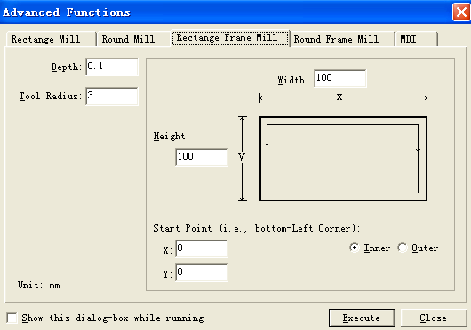

Circular frame mill: like the upper chart shows, after the manager inputs some parameter needed, the system starts to carry out the Circular frame mill function requesting
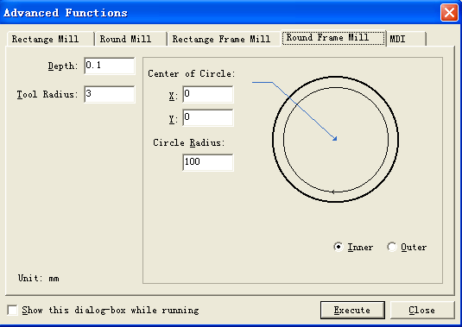

Direct instruction input: This function is prepared for the manager holdings skilled the G code format. The manager may refer to the G instruction introduced in the "Programming Handbook" to use this function.

In here, the manager may carries out some G instruction-code directly. This function is called “manual data input (MDI)” in the numerical control system. Here allows the manager to input the G instruction instant, thus enables the manager to operate the engine bed by the greatest activity. Like the chart shows, the step of which the manager inputs and carries out the current order is:
First, inputting the G instruction with the standard G format, the standard G format refers to the programs handbook please. For example, requests the spindle to return to the position of in 10 mm place upper the workpiece origin, its G instruction is:
G00 X0 Y0 Z10
Inputs the instruction in the editing frame of the current order, then, the mouse click the “execute” button, or presses the “Enter” key, the engine bed can refer to the instruction request to feed to the assigned position.
Once inputting an effective current order, this instruction can be recorded in the current order list. If the instruction that the manager will carried out has already had in the current order list, only needed the left key of the mouse double-clicks the corresponding instruction, it could be carried out.
Jiggle
This function is availability on the pause status in the automatic processing moving process merely. Using not stopping the processing process, but realizes small adjustment of the depth. The operating surface is similar to the manual window.
Calibrator
Using the calibrating function, the manager can determines conveniently the Z coordinates of appropriate workpiece origin as well as adjust the Z coordinates after changing tool. When carrying out this function, chooses the calibrating function from the menu, pop-ups a dialog box, like the chart will show:
In calibrating, first the man determines the processing surface, establishes the processing surface is the workpiece origin of Z direction. Then carries out the first calibrating. Carrying out the second change-tool after the each change-tool.
Carrying on the operation according to the prompt of the chart..
Move to reference point
The mechanical origin is one stationary position of the engine bed, determined together by the mechanical switch and the electrical system, is the zero in the mechanical coordinate system. Refers to 3.2 about the mechanical coordinate system. The execution of the “Move to reference point” the functional needs the hardware support of the engine bed itself, Therefore, certain model engine bed does not support this function. Because the mechanical origin is the benchmark in whole engine bed, Therefore, the vital role of this function consists to adjusting the spot coordinates in current spot coordinates.
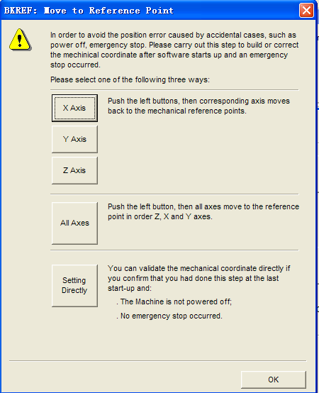

Replacement
At any time, the “replacement” menu item all effective.
Chose this function, the engine bed stopped the current processing duty immediately (if in processing presently), and restored from the warning status (if in warning presently) to the “idle” status.
It is different with the stop function, stop processing with the replacement function, the state of both the spindle in the engine bed and the cooling does not change, also cannot carried out the raise-tool movement.
Attention:
If the “stops tightly” signal in the engine bed hasn’t been relieved, the system cannot restores from the “stop tightly” status. This time, the system prompt: the stop tightly lock has not released.
Disable mechanical limits
This function is used when the system touched the hard limit, shields temporarily the limit function, it is a method of which the engine bed restores the normal position in manual operation. Because the limit function is shielded in this time, therefore the operator must be special caution in using this function.

5.5 “machine” menu
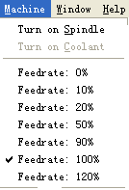
Here the function provided also may be realized in the “numerical control status window”, the reason that the system provides the similar function in the menu is convenient for the manager's keyboard operation.
The concrete function refers to 4.6 please.
5.6 “windows” menu
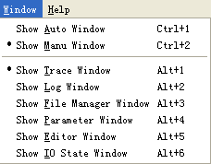

This menu used to carrying on switch in various group windows. The function of each menu item is the significance of its name corresponding.
5.7 “help” menu
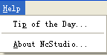

The help menu only have two items at present. One item is “prompts every day”, the other item is “about NcStudio”.
The “Prompts every day” uses in making the brief introduction to the Ncstudio, the “about Ncstudio” uses in prompting various information of the system software, the hardware and so on.
6. Operation step
6.1 starting
Before the start, first determined all connections of the engine bed and computer are normal, then turned on the power in the engine bed and the power in the computer. After the system Finished the initiation, enters the numerical control system of the Ncstudio™.

6.2 machine replacement
Involving this content only in the engine bed that had the function of moving to the mechanical origin and needed, please refer to the engine bed handbook.
If the engine bed supports the operation of moving to the mechanical origin, chooses the “Move to reference point” the menu. The engine bed will returns to the mechanical origin automatic, and revises the coordinates system.
In certain situations, like the previous normal stopping, restarts and continue to carries out the previous operation, the manager does not carry out the mechanical reposition operation. Because, when the Ncstudio™ was exiting in normal, saving the current coordinates information.
Moreover, if the manager confirmed the current position is correct, also does not carry out this operation.

6.3 load processing program
Before in processing, the manager has loaded the processing procedure needed generally, otherwise, the some function related the automatic processing is ineffective.
Choosing the “file (F)| open (O)…” menu, will pop-ups the document operation dialog box of the Windows standard, may chooses the driver, the way as well as the filename of the document which would be opened from this.
After clicking the “open” button, the processing procedure loads to the system. This time, the manager may presses the F2 key, switches to the “processing procedure” window, examining the current processing procedure.
6.4 manual operation
Showed the manual operation surface.
Chose the “view (V)| show manual surface (M)” menu item, the parameter show window will shows a manual operating surface, refers to 5.2, you may carries on the manual operation to the engine bed with this surface.
Manual move
Carrying on the manual operation to the engine bed with corresponding key of numeric small keyboard in the computer. In this time the NUMLOCK lamp should shine on the small keyboard.
The corresponding key is:
６ - X axis directions
４ - X axis negative directions
８ - Y axis direction
８ - Y axis negative direction
９ - Z the axis direction
１ - Z axis negative direction
These keys combined with the CTRL may realize the movement in high-speed to the engine bed.
Increase/decrease depth
Using the +/- key on the small keyboard combined with the numeric keyboard may increase and the reduced the depth fast.
6.5 Determination workpiece origin
In the processing procedure, the origin of X, Y, the Z three coordinates are the workpiece origins. Before in processing, we need to relate this position with the actual location. The step is:
In the engine bed, manual moving the X, Y to the origin position hoped on the workpiece, chooses the “set workpiece origin” menu, or the coordinate in current position to clear in the coordinates window, then, taking the current position as the initial position to carry out when executing the processing procedure
The step in above has completed the workpiece origin establishment of the X axis and Y axis, but Z axis need more precise operating method. This system combined with the hardware in the engine bed to provide to the calibrating function to the Z axis.
Chose the “operate (O)|auto calibrator (E)…” function, completed the automatic calibrating.
The origin of the workpiece processing has already determined by two step operation in above.
6.6 Execution auto processing
The automatic processing refers that the engine bed carry on the processing automatically by the processing procedure selected.
Start to auto-process
Chose the “operate (O)| start or continue (S)” menu item, the engine bed start to carrying out the automatic processing process from the first sentence in the processing procedure automatically.
Engine bed stop
In the automatic processing process, if want to stop the moving of the processing procedure, chooses the “operation (O)|stop (O)”menu item, the engine bed stops to work after the current sentence processing was completed, enters the “idle” status. But this way is the method of which makes the system to precisely and ordered stopping, also is the recommendatory method.
Annotation:
When the connective characteristic of the high smooth speed is effective, the system will stops when the connection speed is zero.
Engine bed stops tightly
In the automatic processing process, if encountering the emergency, chooses the “operation (O)|stop (B) tightly” menu item, the engine bed stops processing immediately, if restart to processing, first must chooses the “operation (O)| restore stop (R)” menu, then chooses again the “operation (O)| start or continue (S)” menu, the engine bed restarts to carrying out the automatic processing process from the first sentence of the processing procedure, otherwise the engine bed can not to work.
The engine bed pause
In the automatic processing process, if need to pause the processing, chooses the “operation (O)| pause (P)” menu item, the engine bed will stop processing after the current sentence has been completed, this time, if continue to carry out the processing procedure only to choose the “operation (O)|start or continue (S)”menu item.
Procedure execute by jump the section
Chose the “advance start (A)” menu item, pop-ups a dialog box, inquires from where to start and where to close in the procedure, if you will filled the sentential number and then clicks the “start” key again, the engine bed only execute certain section of sentences according to in yours request. But before in executing this function sentence must have the segment number.
6.7 Direct localization function
If you want to locate quickly to certain point usually, may tries the “direct localization function” function.
The quick- key of which enters the “direct localization function” function is F5, The quick- key of which exits the “direct localization function” function is Esc
Input the “+”signal in front of X in the “direct localization function” window, realizes the increasing input.
Input the “*”signal in front of X in the “direct localization function” window, realizes the location of the mechanical coordinate.
Input the “@”signal in front of X in the “direct localization function” window, realizes the revising function of the workpiece origin (including increases/ decrease the depth).
.

7. operation attention
7.1 Multi-duty execution attention
Because Windows is the time-sharing operation system, generally speaking in executing the automatic processing may carry on the other work on the computer (like the edition of the processing procedure and so on), but two in following notes please:
(1) The Windows procedure takes the memory quite big, therefore opening window don’t need too many at the same time, generally will be decided by the memory size.
(2) The movement of some application procedure own possibly is not too stable, like some game procedure, the VCD player and so on, they possible to absorb the systemic resources unrestricted in the movement process, like: Memory, the time piece of CPU and so on, finally possibly to cause the computers to end up. Therefore, in the processing process, please do not start these procedures, lest the process interrupt because the computer ends up and causes the accident
7.2 Move to workpiece origin attention
In the process of moving to the mechanical origin, according to the different system request, possibly have the different process. In the system of the precision request quite high, because the precision request is quite high, finally the calibrating process is quite slow, by now need to pay attention to observe the numerical control status window, exited from the window of moving to mechanical origin after the system has entered the idle status, otherwise the process of moving to the mechanical origin haven’t completed normally, stopped by man.
The aftereffect of that the process of moving to the mechanical origin was stopped by man is:
1.Often appears the warning status about the port, because this time the limit signal (mechanical origin) have not released;
2, the localization does not exactly, the calibrating function about the mechanical origin has destroyed by man;
3. The soft limit does not have an effect: Because the process of moving to the mechanical origin has not completed, therefore the man-made soft limit function is invalid in the system in this time, it can be effective while the process of moving to the mechanical origin has completed.

8. End-manager software permission agreement

Permission:
Shanghai WeiHong Science and technology Limited company (named the WH company in following) awards the using right of this software procedure to you. But you must guarantees to own company in following: not in outside the item of this agreement, use, copy, revise, rent or transfers this system or any part in its.
You guaranteed that,
1. Only uses this system on a machine;
2. Only uses on this machine, the purpose of to backup or to manage the records, manufacture the copy of this system in the read format on the machine;
3. Only in the precondition of accepting this agreement and condition by another, convey this system and permissive agreement to another side to use.
4. If happened the transfer, all copies of the original documents and correlative documents must transmit to the opposite, or all copies haven’t conveyed were destroyed;
5. Only in the precondition of one of the following, uses this system in the multi-manager environment or the network system:
This system definite permitted may use in the multi-manager environment or the network system;
Using each node of this system and the terminal all has purchased the using permission.
You guaranteed not to do that:
1. Transfers the permission once more to this system;
2. Carries on the reverse-project, the counter-compiling or the disjoint- teardown to this system;
3. Copies or transmits all or the part of this system, but except the stated agreement.

When you convey this system or all or partial copies of this system to another to use, your permission will be terminated voluntarily.

The copyright and property of this system:
This system and the documents enjoy the copyright, and was protected by the national copyright law and the international agreement item. You do not remove its copyright statement from this software; and guaranteed to (all or part) declare for the copyright of the copies of this system. You agreed to stop copying illegal this system and the documents by any form.

After-sale guarantee:
The WH company guarantees, in the normal using situation, in 90 days from the sold date, the software carrier has not the material or the technologic flaw. If has the flaw after the confirmation, all responsibility of the WH company is exchanges a purchase its software carrier; also is only compensation for yours. Because of the carrier flaw was caused by the accident, abuses or false using, the after-sale guarantee is invalid. The carrier Exchanged a purchase enjoys the surplus time of original guarantee time, or 30 day’s guarantee; Takes the longer first.
Except the content in above, this system does not enjoy the after-sale guarantee by any forms.

The responsibility is limited:
Above guarantees, either the indicating or the metaphor, in order to all content guaranteed, including guarantees to special applied merchandise and adaptability. Regardless of whether follows other provisions of this agreement, because using this system to make: loss of profit, usability lose, commercial interrupt, or any form indirect, special, accidental or inevitable destruction, or any other side’s claim, the WH company and its agent, sold human not to answer for them. Even if the WH company has told that this kind of matter to possible to occur in advance, also have not effect.
Permission termination:
If you disobey any item and condition in this agreement, the WH company terminates the permission at any moment. Before permitting the termination, you mould destroyed all copies and documents of this system immediately, or restored to the WH company.
the suitable law:
《The protecting rules of intellectual property》, 《Copyright, Copyright Law》, 《Exclusive law》, and so on.

Thus, you had read detailed and had understood this agreement, and agreed observes to various items and conditions strictly.

Shanghai WeiHong Science and technology Limited company

9. Appendix: Quick key data sheet
9.1 all quick key

ESC switch between the windows
TAB switch between the control-pieces
Ctrl+ TAB switch In front of folding window

Ctrl+ 1 show auto window
Ctrl+ 2 show manual window

Alt 1+/F4 show track window
Alt+ 2 show log window
Alt +3 show file manager window
Alt+ 4 show parameter window
Alt +5 show editor window
Alt+ 6 show IO window

Ctrl +Enter Full screen
Ctrl +Del clear track window

Ctrl+ O Open and load
Ctrl +N New
Ctrl+ E Open and edit
Ctrl +P Edit loaded file
Ctrl +S Save
Ctrl+I file information

F5 locate directly
F6 Set workpiece coordinate
Shift +F6 Set workpiece origin
F7 Move to workpiece origin
Ctrl +F7 Mobile calibrator
Shift +F7 Fix calibrator
F8 Enter(exit) simulation mode
F9 Start
Ctrl +F9 Advanced start
Shift +F9 Resume
Ctrl+Shift+F9 Execute
F10/Pause Break Pause
F11 Stop
F12 Replacement

9.2 manual windows quick key
ScrollLock Activates manual window
4 (small keyboard) The negative direction of X manual (including spot moves, increase)
6 (small keyboard) The positive direction of X manual (including spot moves, increase)
2 (small keyboard) The negative direction of Y manual (including spot moves,
8 (small keyboard) The positive direction of Y manual (including spot moves, increase)
1 (small keyboard) The negative direction of Z manual (including spot moves,
9 (small keyboard) The positive direction of Z manual (including spot moves, increase)

+(small keyboard) Increases the depth (input numeral)
- (small keyboard) Decrease the depth (input numeral)
9.3 Quick key in trace windows
Home Middle
End show current point
. Or > Enlargement
. Or < Reduction
. (Small keyboard) Switch step length
Alt + → or Alt + ← Circle Z revolving
Alt +↑ or Alt +↓ Circle X revolving
Alt + PgUp or Alt + PgDn Circle Y revolving

