- In this demonstration we will look at Nesting in ArtCAM Insignia. ArtCAM Insignia has a true shape nesting library that allows irregular shapes to fit together as closely as possible.

True Shape Nesting
- Click on Open Model and select Nested dino.art.
- Using the left mouse button, drag a large box around all of the artwork to select all the vectors.
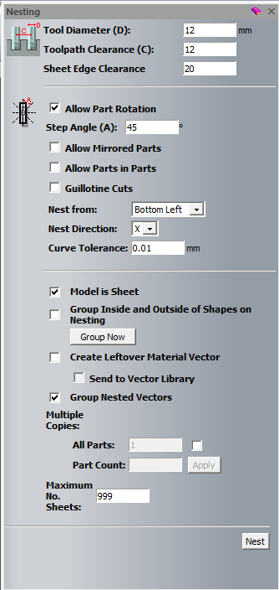
- Select the Nesting function from the Vector Creation toolbar. 
- With the Nesting panel open use the following values:

- Tool diameter (D) - 12mm
- Toolpath Clearance - 12mm
- Sheet Edge Clearance - 20mm
- Check the Allow Part Rotation
- Step Angle (A): 45
- Tick Model is Sheet
- Tick Group Nested Vectors
- Click Nest
- Click on the X to close the Nesting panel

- Now that the shapes are nested together the next step is to apply a toolpath to the piece.
- On the Project panel, click on Toolpaths to show the toolpath creation functions.

- Using the left mouse button, drag a box around all of the vectors to select them all.
- Click on the Profile toolpath function located in the lower half of the panel.
- The Profiling function appears automatically:
- Use the following values:
- Profile option to Outside.
- Offset Allowance - 0
- Start Depth - 0
- Finish Depth - 18
- Tolerance – 0.001
- Click on the Click to Select... to select the Profiling Tool
- The Tool Database appears, select the 6mm End Mill from the Metric Tools - Wood or Plastic – Roughing and 2D Finishing section
- Material Thickness Setup:
- Material Thickness - 18mm
- Material Z Zero – Check top box
- Model Position In Material – Check top box
- OK
- Click Calculate Now
- Click on the X to close the toolpath panel
- The next step is to add tabs/bridges onto the vectors so that the pieces do not fall out of the material after they have been cut out on the machine.
- In the project Panel, click on the plus sign next to the calculated Profile toolpath
- Select Profile toolpath End Mill 6mm
- Click the Profile Options function available at the bottom half of the Project Panel

- The Profile options gets open in the Tools settings: Panel
- Choose Bridges as the option and use the following values:
- Add Bridges To Profiles – Constant Number
- Number – 2
- Bridge Length – 12
- Bridge Thickness – 6
- Make sure 3D Bridges is Unchecked
- Click Create Bridges

- We will now move the bridges to more sensible positions which will be easier to remove it.
- On the 2D View drag the bridges around manually till they are on a straighter section. This can be done by moving the mouse over the centre of each bridge, so that the cursor changes to a circle with a cross going through, Hold the Left mouse button down, and drag the Bridge to straighter section.
- Carry this procedure until all the vectors has the bridges applied on the straight section
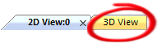
- Press Esc on the keyboard to exit the Profiling options function
- Click on the 3D View Tab to view the toolpath in 3D View with the Bridges applied to it.

- To simulate the piece right click on the Profile toolpath in the Project panel and select Simulate Toolpath.
- ArtCAM Insignia gives you the option to change the resolution of the simulation so you can view the finished piece more clearly, ArtCAM Express has a fixed resolution.

- In ArtCAM Insignia select Simulate Toolpath (ArtCAM Express will do this automatically).
- Select Toolpaths section from the Project panel to view all the toolpath creation functions
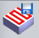
- From the Toolpath Operations section click on the Save Toolpaths function located in the lower half of the project panel to open the Save Toolpaths box.
- From the Machine output file is formatted for: box select your machine from the pulldown and select Save.
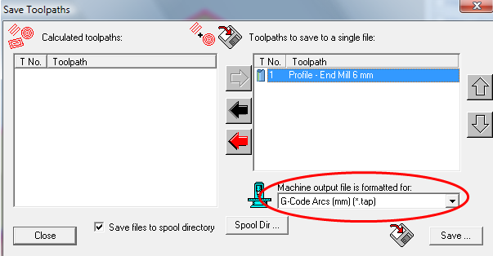
- In the File Name: section type in Dinosaur and select Save to save your toolpath ready to load onto your machine.

